Pusti Bondhu: A Youth-Led Initiative to Improve Campus Nutrition


At Daffodil International University, mornings often begin in a rush. Many students arrive to class without breakfast, either due to time constraints or tight budgets. Soyed Mehedi Hassain Nayeem noticed this pattern during his regular interactions with classmates. Over time, he wondered how these daily habits were affecting students’ concentration, health and learning.
His interest in the issue deepened in December 2024 when he took part in the Training of Trainers programme organized by GAIN and SUN Youth Network Bangladesh. The event brought together young people from forty districts to learn about nutrition, food systems and youth led action. For Mehedi, it offered a new way of understanding student wellbeing on campus.
“The training gave me confidence to take small steps that can lead to big changes,” he said.

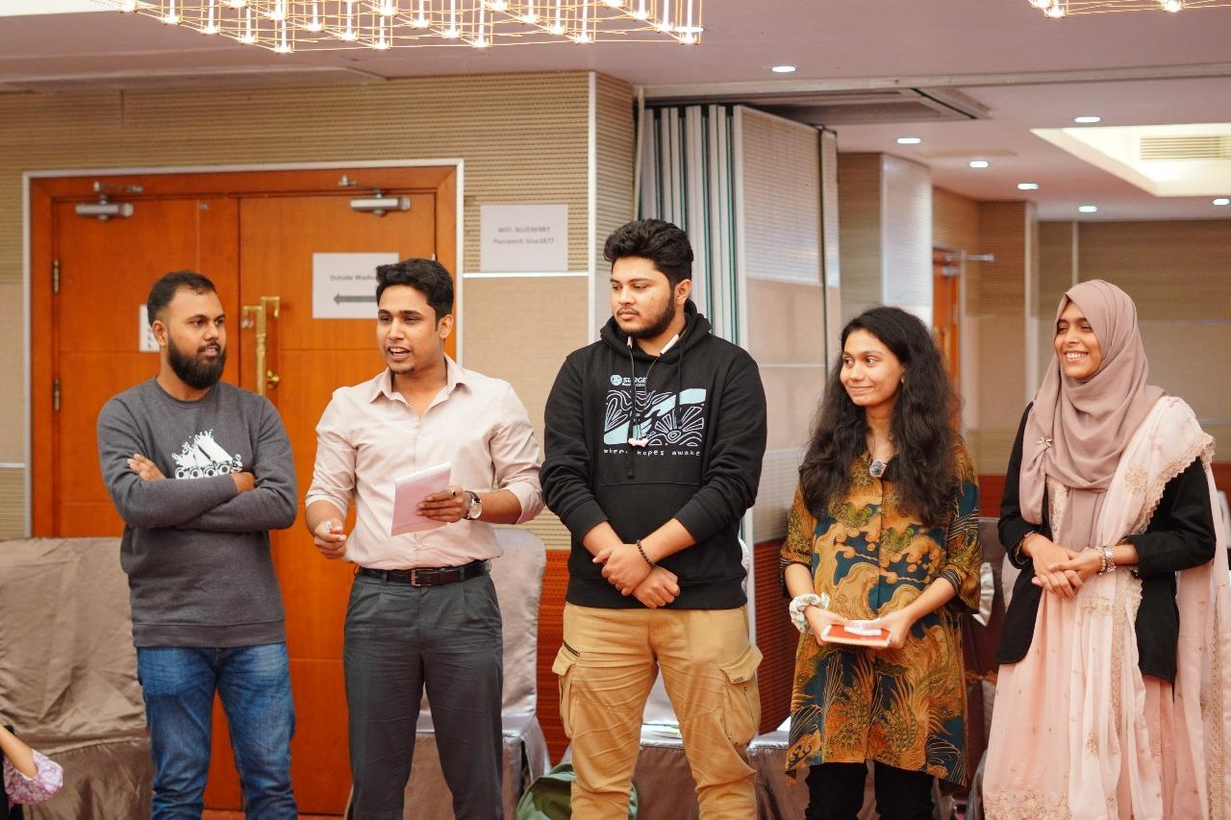
After the training, Mehedi returned to his university with a clearer sense of direction. He conducted informal field visits and short surveys to understand students’ eating habits more closely. The results pointed to the same challenge he had been observing. Many students were skipping breakfast, which affected their energy levels and focus throughout the day.
To help address this, Mehedi created Pusti Bondhu, a campus based initiative offering nutritious breakfast meals at an affordable price of twenty taka. The initiative was supported by GAIN and the Department of Nutrition and Food Engineering at Daffodil International University. Its aim was simple. Make healthy food accessible and convenient at the place where students spend most of their time.
“Many students skip breakfast because they are in a rush or trying to save money. We wanted to make healthy choices easier by placing the solution on campus,” Mehedi explained.
Every morning, students now have access to a filling and affordable meal that helps them stay attentive in class. The project also encourages students to reflect on their eating habits and understand the importance of a balanced diet.
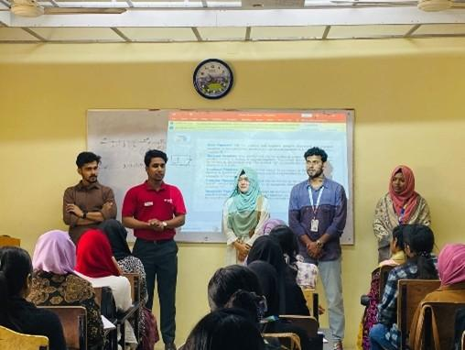

“The most rewarding part of Pusti Bondhu is hearing directly from students how it is changing their day,” he said.
Tasnim Zaman Nody, a student from the Department of Nutrition and Food Engineering, shared, “Earlier, I often skipped breakfast due to high food prices, which made it hard to focus in class. Thanks to Pusti Bondhu, I can have a healthy breakfast for just twenty taka. I feel more active in my classes and my study performance has improved.”
Encouraged by the impact at his own university, Mehedi reached out to other institutions. He conducted Food Systems Youth Leadership sessions at Bangladesh Agricultural University, Barisal University and several other campuses. These sessions introduced students to food systems, nutrition and youth advocacy. Many participants began working on awareness campaigns and exploring their own ideas for small initiatives similar to Pusti Bondhu.
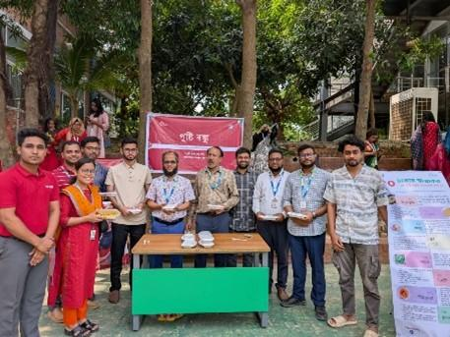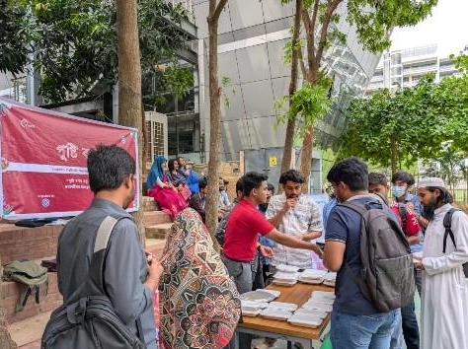
Today, Mehedi serves as a facilitator and youth representative for the SUN Youth Network Bangladesh. He supports new facilitators, shares his experience and helps guide youth led activities across the country.
Mehedi’s journey shows how practical learning, combined with local action, can improve student wellbeing and encourage young people to shape healthier food environments in their own communities.
